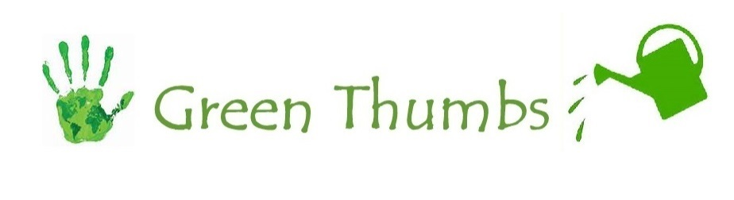
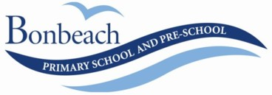

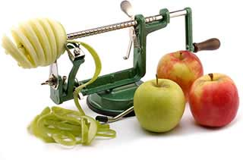
SLINKY MACHINES
Kids love Apple Slinkies because rumour has it apples taste better when they've been put through the Apple Peeler Corer Slicer!
Following on from Wellness Wednesday’s and the popularity of the slinky machines in every classroom, Green Thumbs have secured additional heavy duty slinky machines at a great price of $26, as opposed to the RRP $34.95 plus free delivery & 12 month limited warranty against manufacturer's defects and spare parts available.

If your family would like to purchase a slinky machine, fill in the slip below and return no later than Friday 21st August with your fee of $26 per machine.
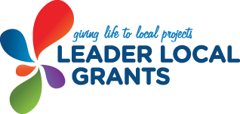
Last year we WON this grant for our chicken coop! This year we want to WIN it for FRUIT & VEGETABLES! Help our school achieve this $1000 grant by following the steps bellow to put fresh fruit & veggies in our kids hands every week!

Green Thumbs believe that putting fresh fruit & vegetables into the hands of young school children is an incredible thing and we would like to do all we can to provide a single serve of fresh fruit to every student once a week at Bonbeach Primary School over the course of a school year.
Help us make a difference!

VOTING OPENS AUG 3RD

Go to http://www.leaderlocalgrants.com.au
-You will need to register before you can vote
-Select Current Ideas – Go to Mordialloc Chelsea Leader
-Select “Bringing fresh fruit back to the classroom”
-Vote with ALL of your 10 votes!
-SHARE the link with family and friends and get them voting!

The more votes we have the better chance we have of winning again!
I would like to purchase a SLINKY MACHINE

Child______________________________________________class:____________________Quantity:_________

Signature of Parent/Guardian:__________________________________________Fee enclosed:______________

