Gardening Club Enrolment Form TERM 3

With Spring approaching, there is lots to learn and do in the garden! Term 3 Gardening Club will commence on Tuesday 21st July. Students will be collected from their classroom and will attend 8 weekly classes of informative, hands-on, fun experiences in both gardening and cooking in our school garden. A green diary for each child will be provided so that you can follow along with their gardening experiences.

- Seeds, Hot Houses & Germination
- Soil Testing & Compost Preparation for Spring
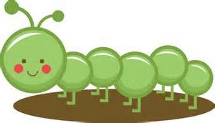
- Planning a Spring Permaculture Garden – what, where & why
- Crop Rotation & Planting Preparation
- Tools & Wheelbarrow license Renewals / Seedling Planting
- Bugs life – building bug hotels for the good the bad and the ugly
- Adventures with your 5 senses
- Harvesting, Preparing & Cooking Fresh Healthy Food

If your child would like to be a member of the 2015 Gardening Club, please return the permission slip below no later than Friday 17th July with your form & fee of $15 per
child - fees sustain the gardening program.

The above program is based upon Organic Schools Australia. Amy & Jade have designed the program to complement our whole school environment. For more information about Australian Organic Schools visit www.organicschools.com.au . Visit the Green Thumbs web page via the school website www.bonbeachps.gov.vic.au for more details or to re-print this page.

I give permission for my child/children to join Green Thumbs Gardening Club Term 3 / 2015

Child_____________________________________________________________class:____________________

Child:____________________________________________________________class:____________________

Signature of Parent/Guardian:_________________________________________Fee enclosed:______________

