Re-Cycled Cardboard Seedling Pots

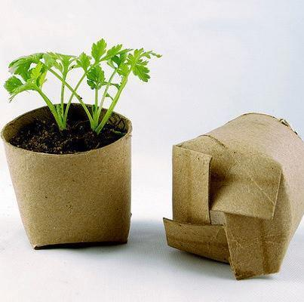
What you will need:
- Cardboard roll or toilet paper roll
- Scissors
- Plastic tray container or egg carton
- Potting mix / dirt / compost
- Texta / pen /pencil
- Water

- Cut 4 even 1cm slits into the bottom of the roll and fold each tag into itself so that it holds
- Fill with your soil and make a hole in the centre with your pen and place 1 seed in to each hole.
- make some holes into the bottom of the container to allow excess water to drain away so that your pots do not become soggy.
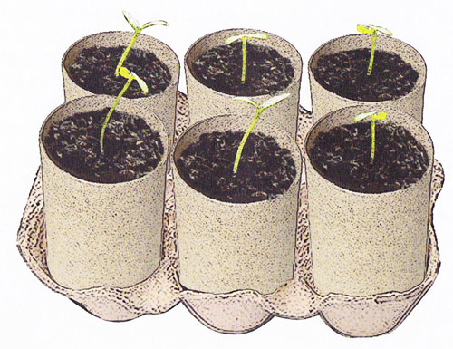
- Place your new recycled / bio-degradable cardboard pots neatly into the tray.

- Label your new plants so we know what you have grown and water it gently.

- Put it in a sunny position and make sure you keep the soil moist and water gently when it appears dry.

- Enjoy watching your new seeds grow! You may even like to take a photo of it and again when you plant it at school!

